#
# 20181107

https://www.poftut.com/linux-mail-mailx-commands-tutorial-examples-send-email-command-line/

Linux mail and mailx Commands Tutorial With Examples and Send Email From Command Line
Posted on 03/03/2017 by İsmail Baydan

Linux have a lot of tools, services and applications related email. Email have different architecture than standard client server. We will look an command line based mailing application named mailx. mailx more advanced version of the mail tool.

General Concept
As stated in previous paragraph email systems are bit more complex than standard client server architecture. There are some terms we should learn before continue
- Mail Client is an application used by user directly to send and get emails. Mail clients connects to the mail transfer agent to transmit emails.
- Mail Transfer Agent (MTA) is an intermedia component used to receive, send, store mail messages. there are some protocol used to accomplish these tasks like smtp,pop3,imap etc.
Below are some architectural view of a simple email transmission.
1 | Mail Client Sender --> MTA of sender --> MTA receiver --> Mail Client Receiver

Syntax
1  2  3  4 | mail.mailutils [OPTION...] [address...]  mail.mailutils [OPTION...] -f [OPTION...] [file]  mail.mailutils [OPTION...] --file [OPTION...] [file]  mail.mailutils [OPTION...] --file=file [OPTION...]

Help
1 | $ mail --help
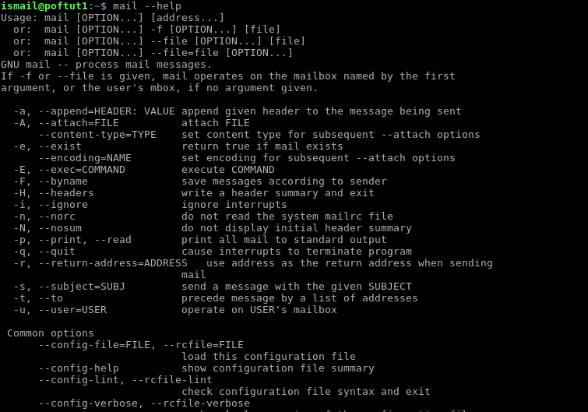Mail Help

Send Email
We will simply mail some text without provide extra information. This is the fastest way to mail also. In this tutorial we will simply use local mail provider but in the SMTP configuration section we will deal with a SMTP server. In this example we will provide subject part of the mail with -s option and we will also provide email address which is the local user named ismail
1 | $ mail -s "Hello World" ismail@localhost
There is a warning which says Null message body; hope that's ok . We think it is ok.

Read Email
In previous example we have send mail to local system user ismail . When user ismail logins to the system he will get a message saying he have an email message. This email can be read from /var/mail/ismail where ismail is the users name with simple cat command.
LEARN MORE Linux stat Command Tutorial With Examples
1 | $ cat /var/mail/ismail
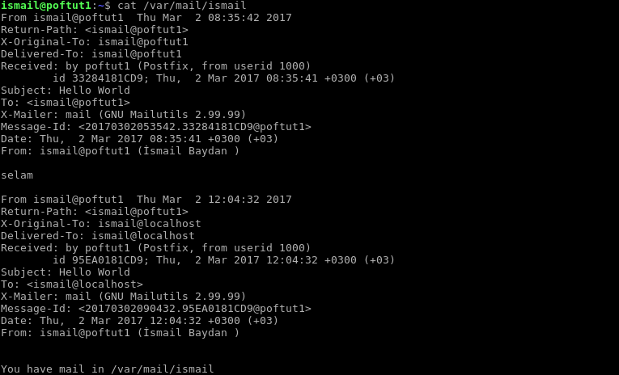

Read Email Body From File
While sending email there will be body part of the mail. This body part can be written by hand. But if it is long and repetetive task we do not want to do always there is an alternative. Body part can be read from a file by simply redirecting the content to the mail command like below. In this example body.txt file contains body part of the mail. This file may also an html file too.

body.txt
1  2  3  4  5 | Hi poftut  How are you? I hope your pageviews are good.  Have a high sessioned day
And we send
1 | $ mail -s "Hello World" ismail@localhost < body.txt
There is other way to send mail by redirecting body content with pipe like below.
1 | $ cat body.txt | mail -s "Hello World" ismail@localhost

Set Multiple Recipient
Another useful feature of mail command is providing multiple recipients by simply delimiting recipients emails. In this example we will send email both to the ismail@localhost and root@localhost . Keep in mind that there may be more than two recipients.
1 | $ mail -s "Hello World" ismail@localhost,root@localhost < body.txt
Set Multiple Recipient
As we can see mail notification is appeared very fast.

Add CC and BCC To The Mail
Carbon Copy - CC and Blind Carbon Copy - BCC are used to send copy of the mail to the other recipients in a visible or hidden way. To provide CC use -c option with email addresses. To provide BCC use -b option with email addresses. In the example we will send mail to the ismail@localhost with root@localhost in CC andtest@localhost in BCC. From this example we will use same options but more featured mailx command.
LEARN MORE How to Setup Kubernetes 1.4 on Ubuntu
1 | $ mailx -s "Hello World" ismail@localhost -c root@localhost -b test@localhost < body.txt
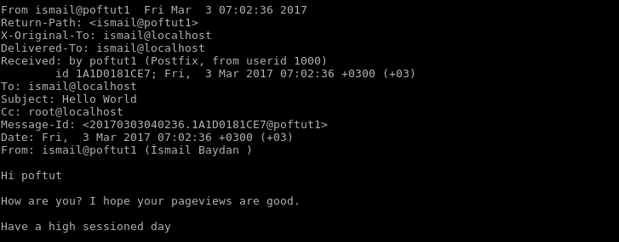CC and BCC
If we look our mailbox we can see mail and cc but can not see bcc

Specify From Name And Address
As we know we can set sender name and email address explicitly. We will use -r option to set sender name and email address. Specify email address like <email@address.com> . In this example we write sender name as İsmail Baydan and sender address as ismail@localhost
1 | $ mailx -s "Hello World" root@localhost -r "İsmail Baydan<ismail@localhost>"
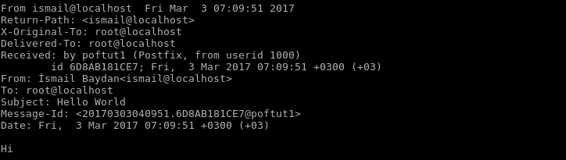Specify From Name And Address
The sender address and name can be seen explicitly.

Specify “Reply To” Address
Reply to address is used to set return address for the mail if the receiver wants to write back. This can be especially useful for automated systems where return will be do a specific email address.Reply to information can be set with -S option. In the example we will set reply to address as ismail@localhost
1 | $ mailx -s "Hello World" -S replyto="İsmail Baydan <ismail@localhost>" root@localhost

Add Attachment
Attachments are crusial part of the email. Emai users generally attaches some documents, image, zip file to the emails to send to the receiver. In GUI email clients it can be easy as copy paste or selecting file. But how can we send email attachments in command line interface. Attachments can be added with-a option with the attachements path. In the example we will add file name a.txt to our mail as attachment.
LEARN MORE How To Get Today's Date?
1 | $ mailx -s "Some File" ismail@localhost -a a.txt
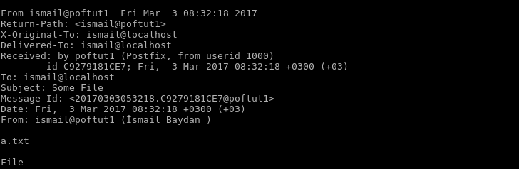Attachment

Use External SMTP Server
Up to now we have used the the local mail system. Local mail system is provided as a simple mechanism by Linux operating system. In the real world examples email system generally uses SMTP, POP3, IMAP services. But in order to send emails we need to setup SMTP server for the mail and mailx command. SMTP configuraiont is put into command line and have some text to type.
1  2 | $ mailx -v -s "This is the subject" -S smtp="mail.example.com:587" -S smtp-use-starttls -S smtp-auth=login \  -S smtp-auth-user="user1@gmail.com" -S smtp-auth-password="1q2w3e" -S ssl-verify=ignore ismail@gmail.com
We will look what this command options and arguments mean.
- -S smtp="mail.example.com:587" specifies the SMTP server host name or IP address and port number which is 587
- -S smtp-use-starttls specifies to use tls encrytion to make communication encrypted and secure
- -S smtp-auth=login specifies what type of SMTP authentication will occur.
- -S smtp-auth-user="user1@gmail.com" specified the username that will be used to authenticate
- -S smtp-auth-password="1q2w3e" specifies the password. Be sure that the system you are using is secure because the clear text password is provided.
- -S ssl-verify=ignore this is used to ignore ssl verification of SMTP server. This option is used to prevent self signed ssl problems. But this makes the operation less secure.

Debug, Troubleshoot and Verbose Output
The general assumption is that there will be problems where sending emails. So wee need to debug to get details of the problem. For both mail and mailx commands. The -v option can be used to debug the mailing operation.
1 | $ mailx -v -s "Some File" ismail@localhost < body.txt

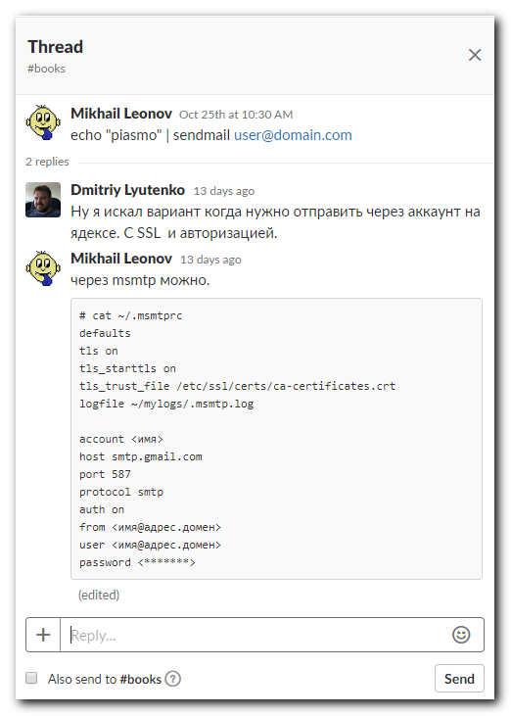
# cat ~/.msmtprc
defaults
tls on
tls_starttls on
tls_trust_file /etc/ssl/certs/ca-certificates.crt
logfile ~/mylogs/.msmtp.log

account <имя>
host smtp.gmail.com
port 587
protocol smtp
auth on
from <имя@адрес.домен>
user <имя@адрес.домен>
password <*******>

